**DAILY ONLINE ACTIVITIES SUMMARY**

|  |  |  |  |  |  |  |  |  |
| --- | --- | --- | --- | --- | --- | --- | --- | --- |
| **Date:** | **06/06/2020** | | | | | **Name:** | **V ANJANA PAI** | |
| **Sem & Sec** | **IV sem & B section** | | | | | **USN:** | **4AL18CS094** | |
| **Online Test Summary** | | | | | | | | |
| **Subject** | | **DATA COMMUNICATION** | | | | | | |
| **Max. Marks** | | **30** | | **Score** | | | **26** | |
| **Certification Course Summary** | | | | | | | | |
| **Course** | **Introduction to Cyber Security** | | | | | | | |
| **Certificate Provider** | | | **Great learning academy** | | **Duration** | | | **5.5 hours** |
| **Coding Challenges** | | | | | | | | |
| **Problem Statement1:** Write a Program in C to rotate an array by N positions.  **Problem statement 2:** Write a Java Program. Given an array A of size N containing 0s,1s and 2s; you need to sort the array in ascending order.  **Problem statement 3:** Write a Java Program to find second-highest number in an array. | | | | | | | | |
| **Status: Executed** | | | | | | | | |
| **Uploaded the report in GitHub** | | | | | **YES** | | | |
| **If yes Repository name** | | | | | **lockdown-coding** | | | |
| **Uploaded the report in slack** | | | | | **YES** | | | |

Online Test Summary: 18CS46 test was scheduled from 9:30am t0 10:10am. The portion for the IA was 5th module there were 30 questions and the time assigned was 40 minutes the questions were mcq type.

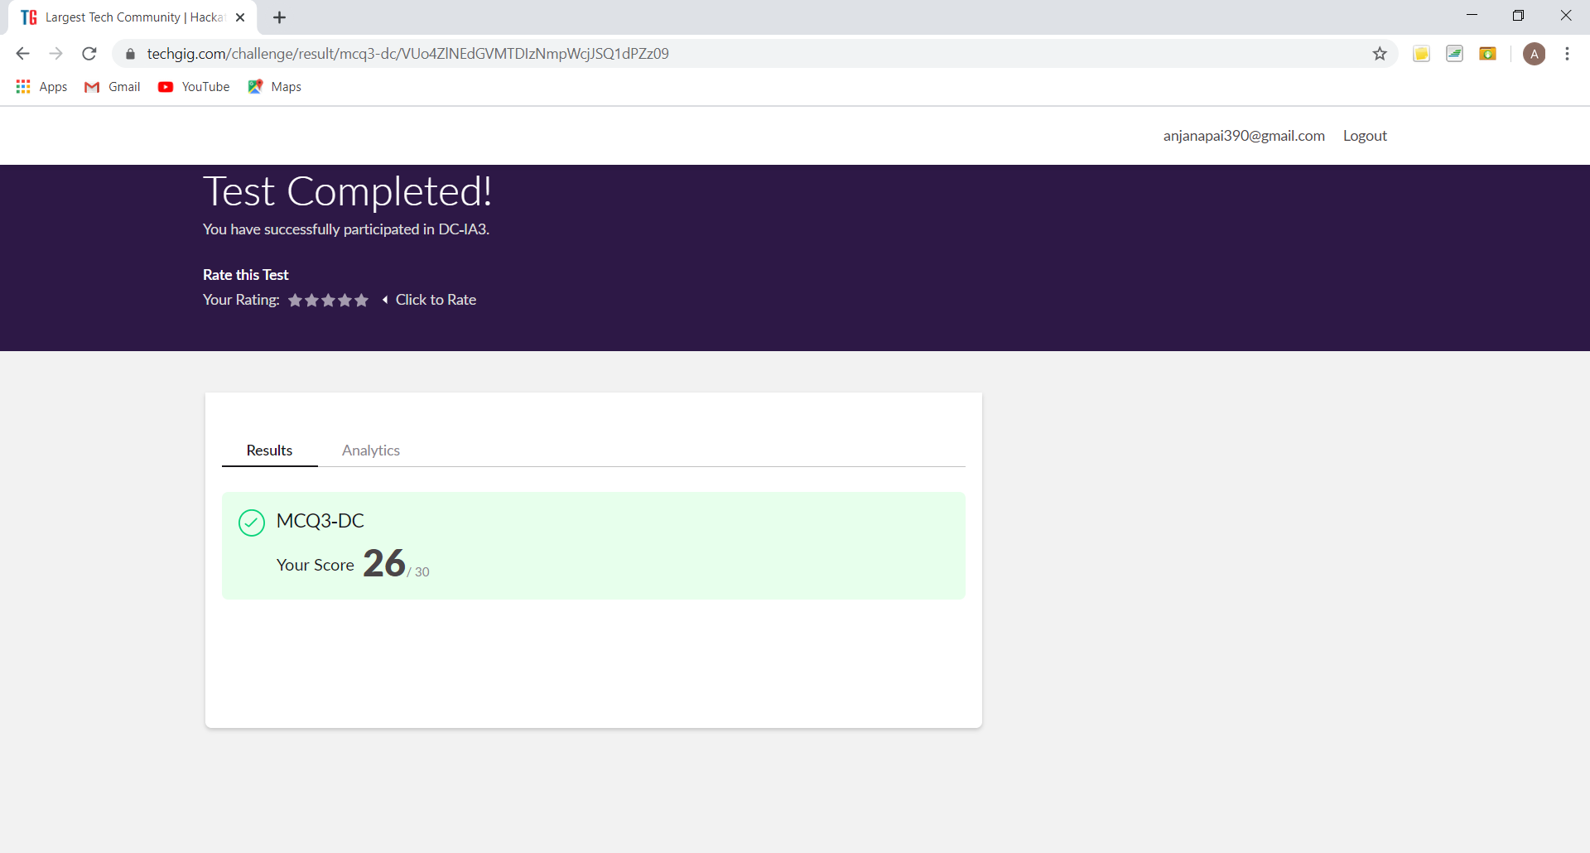

This is the snap shot of completion of test and the marks obtained in 18CS46.

Online Certification Course Summary: Today I registered for a new course that is Introduction to Cyber Security. Where I learnt about the concepts like Blockchain in Cybersecurity and Career Industry Landscape by the Speakers Mr. Raghavendra Puranam and Mr. Aniket Amdekar.

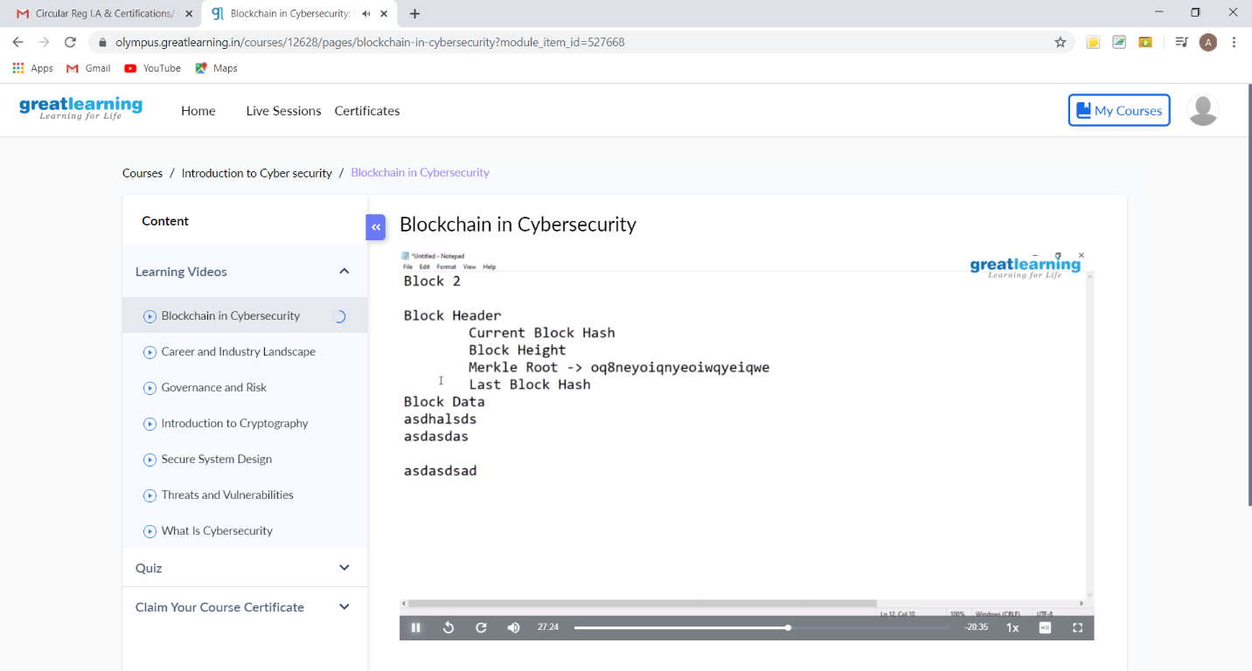

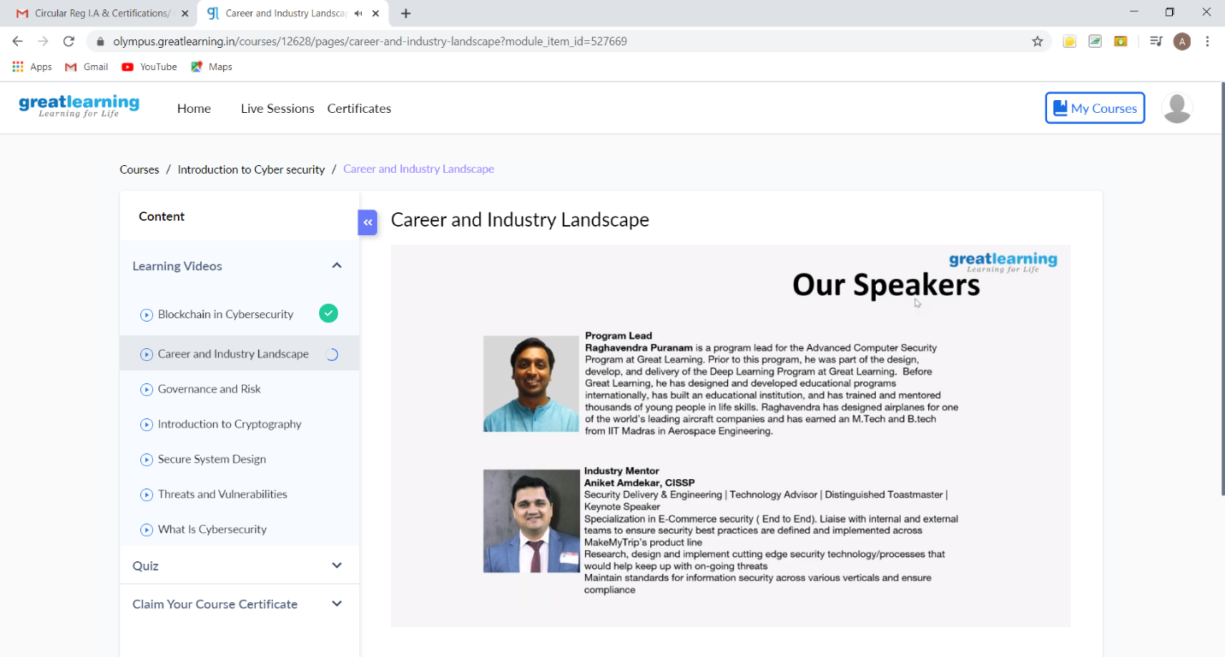

These are the Snap shots of today’s sessions.

Online Coding Summary: **Today I had received 3 programs from prof. Shilpa CSE Dept, prof. Venkatesh CSE Dept and prof. Reena Lobo CSE Dept. The programs are mentioned above in the coding challenges(pg.01). I have also uploaded it to my GitHub repository.**

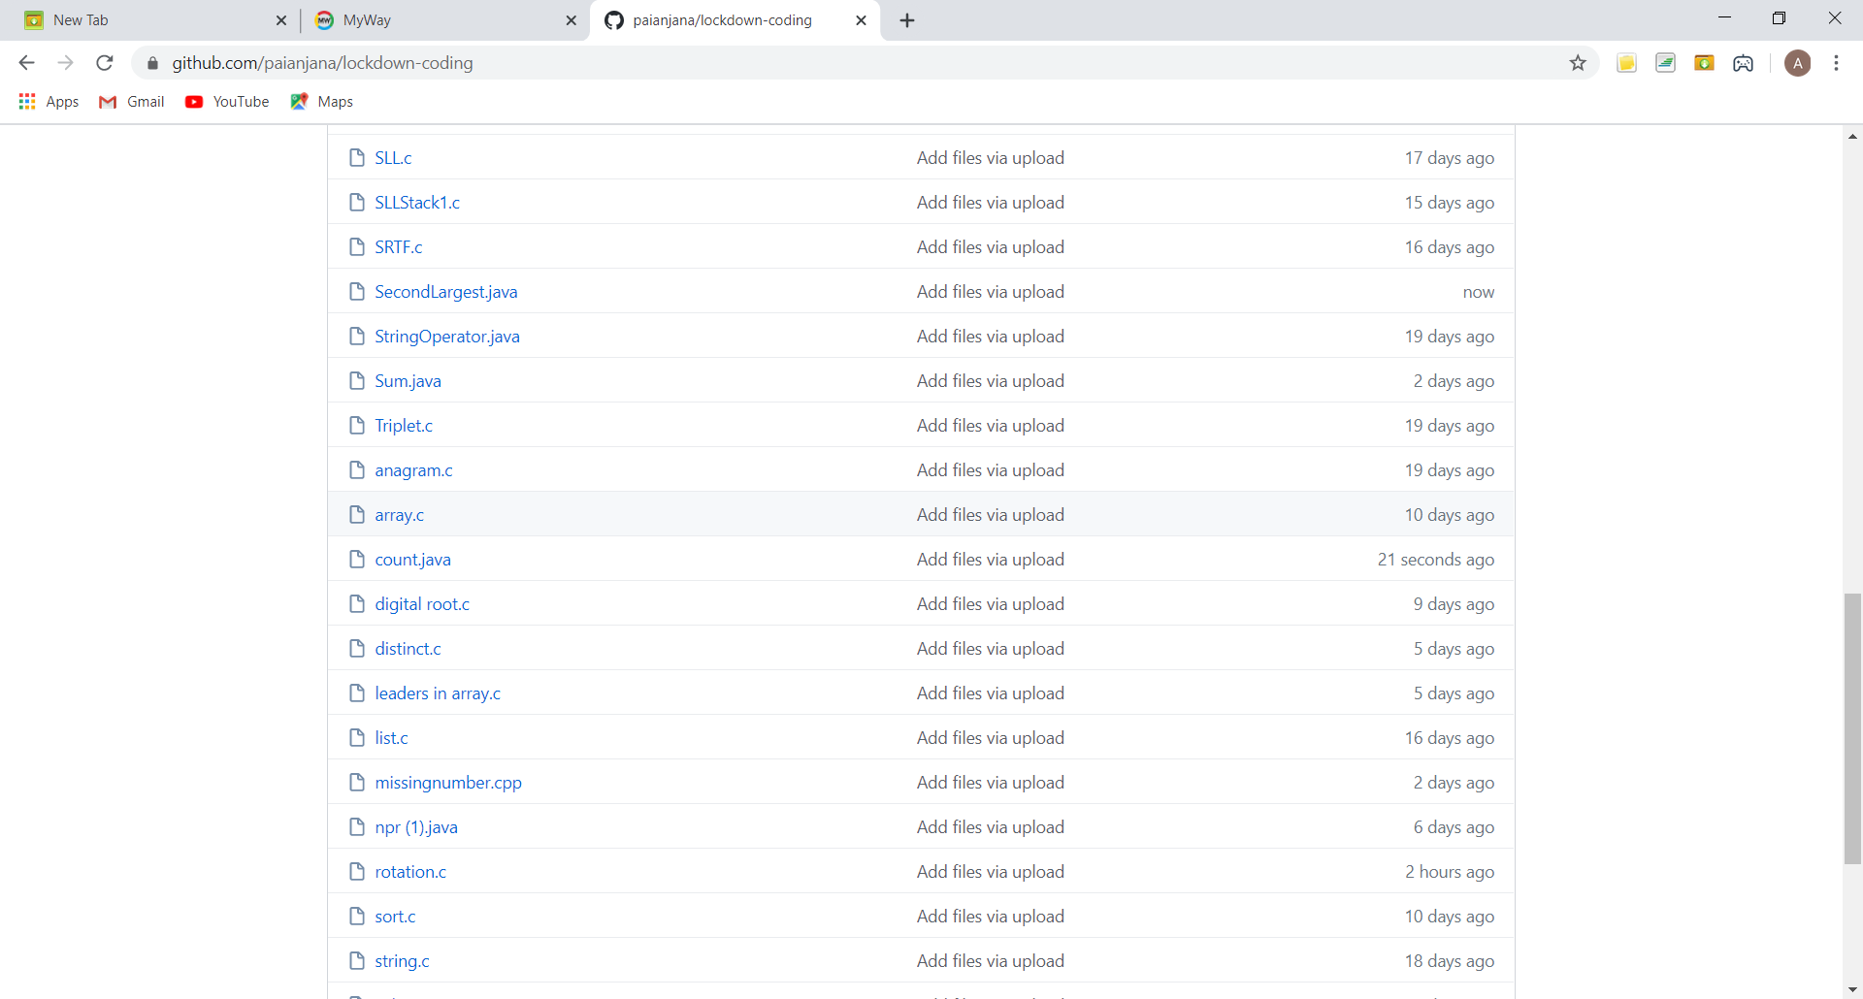

This is the snap shot of my repository where I have uploaded the code. File name is count.java, SecondLargest.java and rotation.c